**PROJECT REPORT : Bright ideas consulting**

INTRODUCTION :

The company approached Bright Ideas Consulting to streamline their operations, reduce costs, and position themselves for sustainable growth in an increasingly competitive market.

PURPOSE :

Bright Ideas Consulting works to help clients streamline operations, improve processes, and enhance overall efficiency. This is done to maximize resource utilization and improve the bottom line.

SCOPE:

The project focused on key departments including Operations, Finance, Human Resources, and Technology. Our approach involved a thorough analysis of existing processes, systems, and organizational structure.

OBJECTIVES :

PROVIDE SPECIALIZED EXPERTISE: Offer clients access to a team of experts with specialized knowledge and skills in a particular industry or functional area.

SOLVE BUSINESS CHALLENGES: Assist clients in identifying, analyzing, and resolving specific business problems or challenges they are facing.

DRIVE EFFICIENCY AND OPTIMIZATION: Help clients streamline operations, improve processes, and enhance efficiency to achieve better results and maximize resources.

ADVANTAGES

Specialized Expertise: Bright Ideas Consulting brings a team of experts with specialized knowledge and skills in specific industries or functional areas. This expertise can provide clients with valuable insights and solutions to complex business challenges.

Objective Perspective: As an external entity, Bright Ideas Consulting can provide an unbiased and objective view of the client's business operations, processes, and challenges. This fresh perspective can lead to innovative and effective solutions.

Cost-Effective Solutions: Engaging with a consulting firm can often be more cost-effective than hiring full-time employees with the same level of expertise. Clients can access a range of skills and knowledge without the overhead costs associated with permanent hires.

DISADVANTAGES

COST CONSIDERATIONS: Consulting services can be expensive, and clients may need to carefully weigh the cost against the potential benefits. It's important for clients to have a clear understanding of the expected return on investment.

DEPENDENCE ON EXTERNAL EXPERTISE: Relying heavily on external consultants may lead to a dependency on their expertise, potentially hindering the development of in-house capabilities.

LIMITED UNDERSTANDING OF COMPANY CULTURE: External consultants may not have the same level of familiarity with a company's culture, values, and internal dynamics, which can impact the implementation of recommended solutions.

BRAINSTORMING :

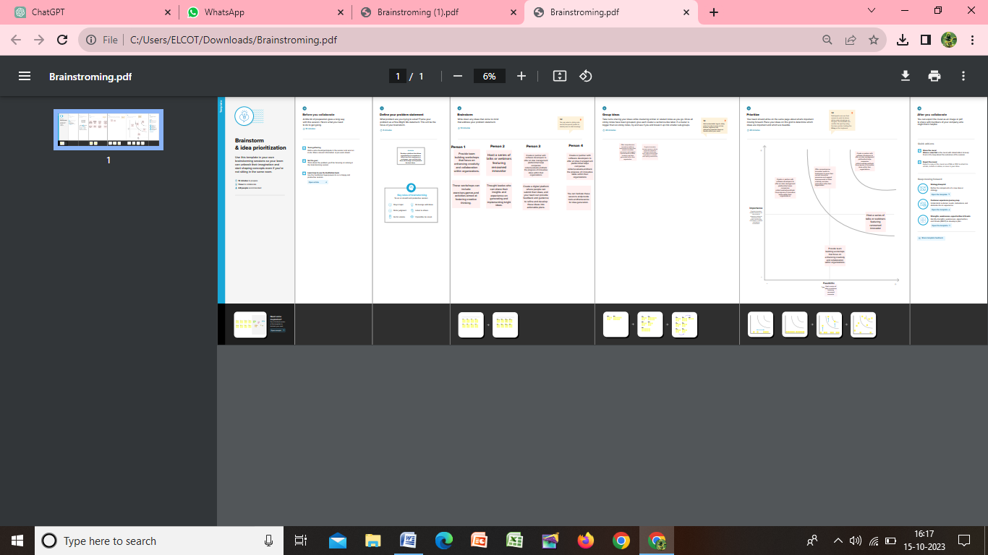

EMPATHY MAP :

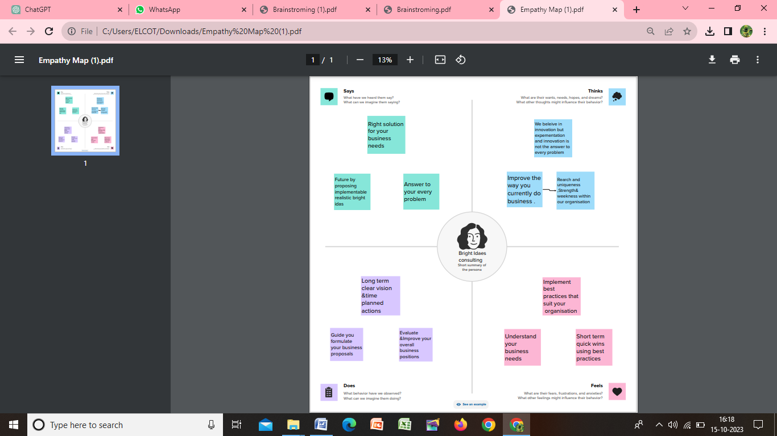

CONCLUSION:

In conclusion, Bright Ideas Consulting has demonstrated its commitment to providing exceptional consulting services tailored to the unique needs and challenges of our clients. Throughout the duration of this project, our team of experts worked diligently to deliver valuable insights, innovative solutions, and practical recommendations.

Source :

https://github.com/SujaMalu/Bright-Ideas-Consulting